EXPERIMENT-3
NAME:Mithun Raj D ROLL NO:240701315

1.COMMAND LINE INTERFACE:
PYTHON CODE:
import os
import sys

def rename_file(old_name, new_name):
try:
os.rename(old_name, new_name)
print(f"File renamed from {old_name} to {new_name}")
except FileNotFoundError:
print(f"Error: {old_name} not found.")
except Exception as e:
print(f"An error occurred: {e}")

if __name__ == "__main__":
if len(sys.argv) != 3:
print("Usage: python rename_cli.py <old_filename> <new_filename>")
else:
rename_file(sys.argv[1], sys.argv[2])
OUTPUT:
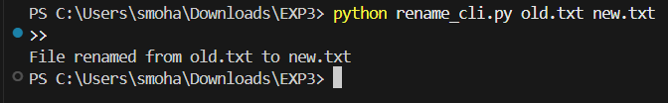

2.GRAPHICAL USER INTERFACE:
PYTHON CODE:
import tkinter as tk
from tkinter import messagebox
import os

def rename_file():
old_name = old_entry.get()
new_name = new_entry.get()

if not old_name or not new_name:
messagebox.showwarning("Warning", "Enter both filenames")
return

if not os.path.exists(old_name):
messagebox.showerror("Error", "File not found")
return

os.rename(old_name, new_name)
messagebox.showinfo("Success", "File renamed successfully")

root = tk.Tk()
root.title("File Renamer")
root.geometry("350x150")

tk.Label(root, text="Old Filename").pack()
old_entry = tk.Entry(root)
old_entry.pack()

tk.Label(root, text="New Filename").pack()
new_entry = tk.Entry(root)
new_entry.pack()

tk.Button(root, text="Rename File", command=rename_file).pack(pady=10)

root.mainloop()

OUTPUT:

